**Blackhawk COLOR RUN**

**2016 Fundraising event Sunday, May 22nd**

**Fund color 5k Run/Walk at Brandon Community Park at Hadley**

**Events**:

9:00 AM – Volunteers report: Site set up

11:00 AM – Participants report:

12:00 PM -Start of run/walk event 5k

2:00 PM- clean up

**Entry Fee:**

$35 for all participants

Resent this from on the packet pick up day, Saturday May 21st of else before the race Sunday May 22nd

Blackhawk COLOR RUN 2016 Fundraising event  Run/Walk will begin and end at the Brandon Community Park located at the intersection of Oakwood and Hadley Road. It is a two loop 5 kilometer route. Maps will be provided on race day.

100% of proceeds from this event goes to the Ortonville-Brandon High School Girls Cross country and Track teams. We intend to put together an enjoyable event for all participants of any age and athletic ability. Runners, joggers and walkers are all welcome and encouraged  to participate. Bring your friends and family to our event! This Run/Walk is a color run, be sure to wear all white to show off your colors at the end of the race!

Packet pickup will be on Saturday May 21st at 3-6pm and at 9:30-11:30 am race day.

**A t-shirt and goodie bag will not be guaranteed to any and all participants who chose to register after the April 23rd deadline.**

**In the event of inclement weather, the race will be cancelled at the digression of the race director. All purchases and registration fees are non-refundable.**

*For Office Use Only*

Ck # ___________ Amt. $______________

Date ___________ Initials______________

Bib#__________________________________

**Please Make Checks payable to:**

***Brandon Township Parks & Recreation*** and mail to:

P.O. Box 929, 395 Mill St

Ortonville, MI 48462

Blackhawk COLOR RUN 2016 Fundraising event Run/Walk Entry Form

Name _________________________________________

Address _______________________________________ City _________________________ State ____ Zip _____ Phone _________________ Sex __ Age on 5/22/16 ___

*WAIVER: I fully understand that running a trail race with extreme obstacles including but not limited to steep hills, walls, rough terrain, and low structures is a potentially hazardous activity. I should not enter and run unless I am medically able and properly trained to safely complete the event for which I am submitting this entry form and fee. I agree to abide by any decision of a race official relative to my ability to safely complete this run within the designated time limit. I further agree to surrender my race bib and timing chip (if timing chips are assigned to participants in this event) to any race official if directed to do so for any reason. I assume all risks associated with participating in this race, including, but not limited to: falls; contact with other participants; the effects of weather, including heat, cold, or precipitation; vehicular traffic; the condition of the roads and/or trails; all such risks being known and appreciated by me. I agree not to consume alcohol or ingest any other substance that will inhibit my mental or physical ability prior to the Blackhawk COLOR run 5k. I agree to obey all civil and criminal laws and exhibit appropriate behavior at all times. I consent to emergency medical care and transportation in order to obtain treatment in the event of injury to me as medical professionals may deem appropriate. I hereby grant permission to use any photo or video recording taken of me at this event for use in advertising, marketing and/or promotion of the Blackhawk COLOR run 5k. Having read this waiver and knowing these facts and in consideration of your accepting my entry, I for myself and anyone for whom I am entitled to act waive, release, and hold harmless the race organizer, all other sponsors and property owners, Brandon Township, Brandon Community Park Club and all the agents, employees, officers, directors, and volunteers working for those entities from all claims and liabilities of any kind arising out of or related to my participation in this event. I also understand that strollers, roller skates, and pets are not allowed on the course at any time during this event. I acknowledge that I have carefully analyzed, accepted, and agreed to the terms of this Release and Liability waiver, know and understand their contents, and sign on my own free act and deed.*

Signature_____________________________ Date _______

*of parent or guardian if under 18 yoa*

Email ________________________

Entry Fee $ ____________ Event: □ Adult □ Child

Registration not refundable or transferable under any circumstance.

Shirts: (circle one)

Adult T-shirt size Youth T-shirt size:

S M L XL XXL XXXL XXXXL XS S M L

**Blackhawk Color Run 5k fundraising event!**

**Join us on May 22nd for Ortonville-Brandon's first color run 5k!  
Athletes of all ages and ability are able to join in on the fun!   
Be sure to "like us" on Facebook and check out our webpage for more information.**

**This event is a nonprofit fundraiser. All proceeds will be donated to the Brandon girl’s high school cross country and track teams.**

[**http://blackhawkcolorrun.weebly.com/contact.html**](http://blackhawkcolorrun.weebly.com/contact.html)

[**https://www.facebook.com/BlackhawkColorRun**](https://www.facebook.com/BlackhawkColorRun)

**Runners can register online at:**

[**www.runsignup.com**](http://www.runsignup.com)

**Brandon Township Parks & Recreation**

**(248)627-4640**

**Proceeds will be donated to the Brandon High School Girls' Cross Country and Track teams!**

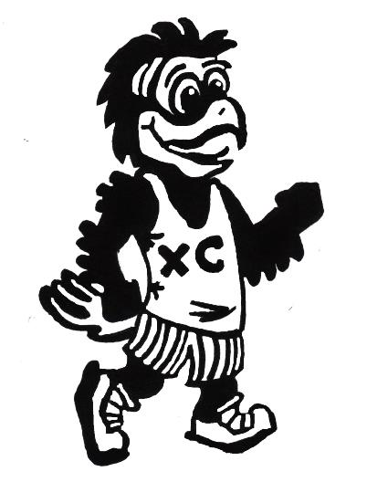

**Request for sponsors:**

**We need your help! Our race requests support from the businesses and charitable donors of the Ortonville-Brandon community and the surrounding area. All local businesses and any individuals interested in assisting our cause have the opportunity to contribute funds to help benefit our race.   All donating business and charitable individuals can pay to have their name printed on to the back of our Blackhawk COLOR run racing t-shirt. Thank you for your consideration**

**Call for volunteers!**

**We need everyone willing and able to help us make this event a success. If you do not wish to race, we encourage anyone and everyone to join our volunteer staff.  
We need all the help we can get for course set up the day before the race on Saturday, May 21st, as well as on race day.  
National Honors Society members are welcome and encouraged to volunteer for our organization.**